- Trash Bags. Buckeye Trash Solutions (BTS) feels that their new, improved 30 gallon trash bag will be the strongest bag on the market if the new trash bag’s mean breaking strength can be shown to be at least 50 pounds. A random sample of 40 new, improved trash bags reveals $\overline{x}=50.575$ lbs. Assume $σ=1.65$.
- Define $μ:$this represents the true mean for the weight of the improved gallons which is given as 50 in our case.
- Calculate 95% and 99% confidence intervals for $μ$.
CI at 95% is: 50.575±z (0.025) *1.65/ √40 =50.575±1.96*1.65/√40= (50.064,51.086)
CI at 99% is: 50.575±z (0.005) *1.65/ √40 = 50.575±2.576*1.65/√40= (49.903,51.247)

- Can BTS be 95% confident that $μ$ is 50 lbs? Explain.
Yes, since 50 is within the limits (50.064,51.086), we are 95% that the mean is at least 50 lbs.

- Can BTS be 99% confident that $μ$ is 50 lbs? Explain.
Yes, since 50 is within the limits (49.903,51.247), we are 99% that the mean is at least 50 lbs.

- Based on your answer to c) and d), how convinced are you that the new 30-gallon trash bag is the strongest such bag on the market?
Since in both cases, the $μ$of 50 lbs. is within the 95% and 99% confidence intervals, it is a sure proof that the 30-gallon trash bag is the strongest in the market.

- Estimate the sample size needed so that a 99% confidence interval would be (50, 51.15). Show all work.
No. = ((Z²pq)/e²)
SE = 1.65/√40 = 0.2609
MOE = 2.576*0.2609 = 0.6720
No. = ((z*δ/ME) ^2
No. = ((2.576*1.65)/0.6720) ^2 = 40.0

- Debt-to-Equity Ratio. One measure of a company’s financial health is its debt-to-equity ratio. This quantity is defined to be the ratio of the company’s corporate debt to the company’s equity. If this ratio is too high, it is one indication of financial instability. For obvious reasons, banks often monitor the financial health of companies to which they have extended commercial loans. Suppose that, in order to reduce risk, Loans-R-Us has decided to initiate a policy limiting mean debt-to-equity ratio for its portfolio of commercial loans to being less than 1.5. In order to estimate the mean debt-to-equity ratio of its current commercial loan portfolio, the bank randomly selects a sample of 15 of its commercial loan accounts. Audits of these 15 companies sampled result in the following debt-to-loan ratios:
1.31 | 1.05 | 1.45 | 1.21 | 1.19
1.78 | 1.37 | 1.41 | 1.22 | 1.11
1.46 | 1.33 | 1.29 | 1.32 | 1.65

  - Describe the normality of this data. Support your assessment with at least one graph. (Refer to Lab 7).
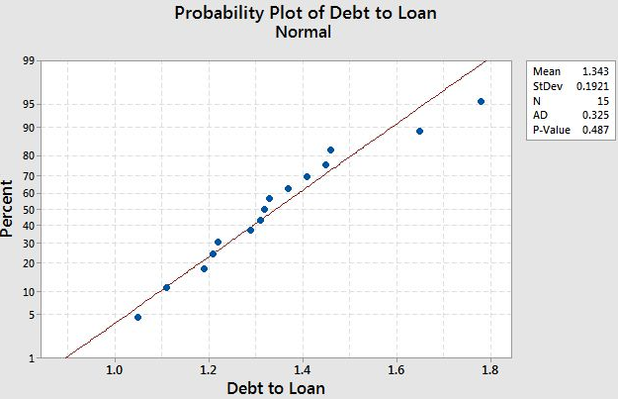

From the graph, we can conclude that the data is normally distributed with p-value being greater than the significant level of 0.05

  - What is the parameter Loans-R-Us wishes to estimate?
No. = 15
Mean = summation of X_{i}/n = 1.3433
Standard deviation s = √summation of (Xi – X bar) ^2 /n -1 = 0.192081
Standard error s_{e} = S/√ n = 0.192081 / √ 15 = 0.049595

  - Find a 95% confidence interval.
Df = n -1 = 14
T- critical: t_{0.05}/2.14 = 2.14479
CI: X Bar ± t*S_{e} => 1.34333 ± 2.14479*0.049595
CI: (1.236962, 1.449705)

  - Based on the interval, is Loans-R-Us in compliance with its new policy?
Notably, the interval range is less than 1.5, therefore, we reject H0. Therefore, the test statistic is significant considering 1.5 is not within the confidence interval range.

- Humor in Television Ads. In the Journal of Advertising, the use of humor in television ads in the United States was compared with the use of humor in television ads in the United Kingdom. It was found that a substantially greater percentage of U.K. ads use humor.

- Suppose that a random sample of 400 television ads in the United Kingdom reveals that 142 of these ads use humor.

    - Define p: is the population proportion which in our case is 142/400

    - Construct a 95% confidence interval for this parameter.

Point estimate (Ṕ) = 142 / 400 = 0.355
p ± z_{α/2}√((p)(1-p)/n)
= 0.355 ± 1.96√ ((0.355) (0.645)/400)
= 0.355 ± 0.047
= [ 0.308, 0.402]

- Suppose a random sample of 500 television ads in the United States reveals that 122 of these ads use humor.

    - Define p: this is the population proportion and is given by 122/500 = 0.244
    - Construct a 95% confidence interval for this parameter.
= p ± z_{α/2}√((p)(1-p)/n)
= 0.244 ± 1.96√ ((0.244) (0.756)/500)
= 0.244 ± 0.038
= [0.206, 0.282]

- Do the confidence intervals you computed in a) and b) suggest that a greater percentage of U.K. ads use humor? Yes. Explain. The proportion of all U.K. television ads that use humor is greater than the confidence interval for the proportion of all U.S. television ads that use humor. Notably, the lower confidence interval for the U.K. is greater than the upper confidence interval for the U.S. How might an ad agency use this information? The information is useful for the ads agencies to enable them to use more humor in their ads to catch more viewers.

- Determine the sample size needed in order to be 90% confident that the sample proportion of ads using humor in the United States is within .04 of p.

No. = ((Z²pq)/e²)
No. = ((1.645) ^2(0.244) (0.756)) / (0.04) ^2
No. = 0.499164195 / 0.0016
No. = 311.97
No. = 312

